【例4-78】进行二维适应性去噪过滤处理
I = imread('saturn.tif');
J = imnoise(I,'gaussian',0,0.005);
K = wiener2(J,[5 5]);
imshow(J)
figure, imshow(K)
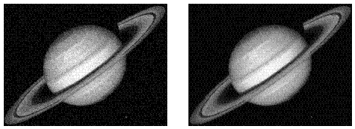
适应性去噪过滤

